 | Custom Diffraction Gratings
Enabling Compact, High-Throughput Blazed Gratings for Space Science
About Inprentus  Inprentus is a small business in Champaign, Illinois manufacturing blazed diffraction gratings. Founded in 2012 by University of Illinois professor Peter Abbamonte, Inprentus uses proprietary, digital ruling technology with dynamic contact mode lithography. With over 100 gratings delivered to synchrotron, FEL, semiconductor, and space research facilities worldwide, Inprentus is the trusted partner for next-generation blazed diffraction gratings.  The challenge for space instruments  Space-based spectrometers face strict size, weight, and performance constraints in addition to needing components that are ultra-high vacuum compatible. Flat gratings require multiple additional optical elements, adding mass, complexity, and alignment risk. Dim stellar and solar targets demand maximum light throughput, leaving no room for efficiency losses.  Our solution: curved & blazed gratings  Inprentus has developed a breakthrough technology to manufacture custom blazed diffraction gratings on curved surfaces, enabling a 2-in-1 optical element that combines the mirror-like focusing with the dispersive function of a grating.  - Compact Design: Curved gratings eliminate the need for separate focusing optics, enabling more compact instrument designs.  - High Throughput: Blazed groove profiles concentrate diffracted light into the desired order, ideal for photon-starved targets such as dim stars.  - Nanometer Precision: Grooves placed with < 100 nm precision over hundreds of thousands of lines ensure diffraction-limited resolving power.  - Unique Capability: Inprentus is the only known manufacturer of curved blazed gratings with variable line spacing, high line density, and < 1 nm rms roughness that are ultra-high vacuum compatible.  Proven heritage  In 2025, Inprentus was awarded a NASA SBIR Phase III contract to make 12 spherical gratings for the ESIS-II sounding rocket mission. The gratings will enable simultaneous 6-channel EUV imaging of the Sun. | Inprentus curved blazed grating technology  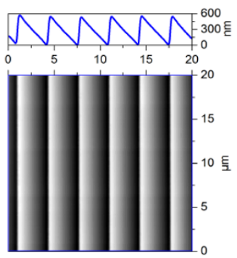  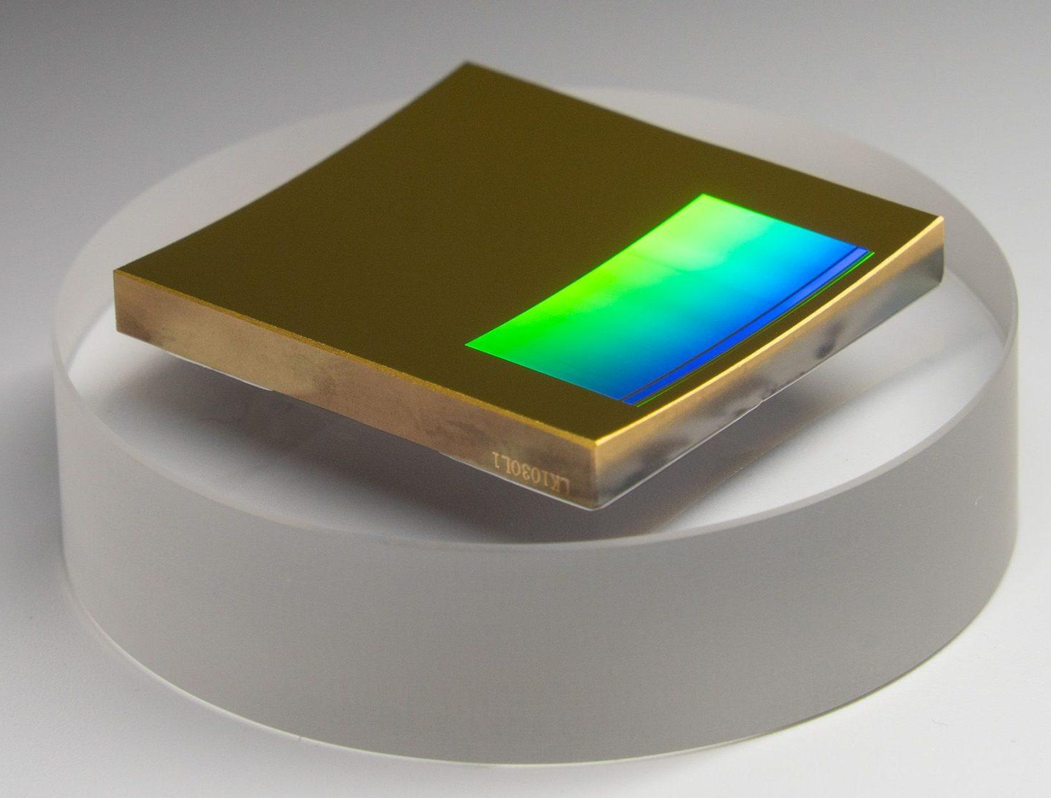  Inprentus uses a 9-axis CNC, with digital motion control and interferometry, typically found in the semiconductor industry, to create blazed structures in a semi-automated fashion. In-situ AFM imaging, and dynamic scribe control provide unparalleled range of customization options resulting in high efficiency, low stray light (comparable to holographic gratings), high spectral resolution, and focusing power with curved and free-from gratings.  Key technical capabilities  Wavelength range: Soft X-ray, UV, Visible light, IR  Groove density: 50 lines/mm to 6000 lines/mm  Blaze angle range: 0.1° to 90°  Surface roughness: < 1 nm rms  Stray light: < 0.2% (over 2π steradian)  Resolving power: Diffraction-limited; > 100,000  Substrate size: Up to 500 mm × 200 mm  Radius of curvature: Down to ~100 mm & free form  Pitch uniformity: < 20 pm  Why Inprentus for NASA / space research?  - NASA heritage: Phase III contract for ESIS-II; experienced with space-grade optics  - Efficiency guarantee: Minimum 75%, typically 90% of theoretical ideal, simulations validated by at-wavelength measurements  - Fast turnaround: Industry-leading delivery times with rigorous QA and FAT reporting  - UHV compatible: ISO 6 cleanroom; double-bagged, shock-monitored packaging for flight hardware  - Design and manufacturing expertise: Agile team with 10+ years of experience with custom diffraction gratings.
Contact  info@inprentus.com  +1 (217) 239-9862 | Address  51 E. Kenyon Road  Champaign, IL 61820 | Web  www.inprentus.com  www.linkedin.com/company/inprentus

